Employee Onboarding

Escalation & Fallback Technical Approach

Sprint 2
AI Assistant for HR
Nihal Reddy
Dev 2

Table of Contents
Purpose 3
Fallback and Low-Confidence Behaviour 4
Out-of-Scope and Sensitive Cases 5
Escalation Trigger and Human Handoff Flow 6
User-Facing States 7
Open Questions / Implementation Considerations 9

Purpose
The purpose of this technical approach is to define how the Employee Onboarding Assistant should behave when it cannot safely provide a normal supported answer to an employee.
The Sprint 2 Core MVP is focused on Employee Onboarding as the selected use case. The expected end-to-end journey is for a new employee to access the onboarding assistant, ask an onboarding-related question, have the system retrieve relevant approved onboarding information, and receive an appropriate response. When the assistant cannot appropriately answer the question, the system must instead provide fallback guidance or direct the employee towards human support.
This task focuses specifically on that final decision point. It defines how the application should distinguish between a question that can be answered normally, a question that requires clarification, a question that is unsupported, a sensitive matter that requires human involvement, and a technical failure where the AI or retrieval process is unable to complete successfully.
Not every employee question should be answered automatically. Some questions may be unclear, unrelated to onboarding, unsupported by the approved information available to the MVP, technically impossible to answer at that moment, or sensitive enough to require human judgement. The system therefore needs a controlled way to decide when to answer normally and when to stop the normal automated flow.
This technical approach defines that decision behaviour. It focuses specifically on supported answers, clarification, fallback, escalation and technical-error handling so that the assistant does not guess, create unsupported HR information or imply that it has authority beyond the agreed MVP scope.
This document focuses on the decision behaviour that occurs after an employee question is processed. It defines the appropriate system outcome based on whether the question can be safely answered, requires clarification, is unsupported, requires human assistance, or cannot be processed because of a technical failure.

Fallback and Low-Confidence Behaviour
The assistant should only provide a normal answer when the employee has asked a supported onboarding question and there is sufficient approved information available to support the response.
For Sprint 2, low confidence should not be based on an arbitrary numerical threshold because the final requirements do not currently define a specific confidence score. Instead, low confidence should be treated as a situation where the system does not have enough reliable information to provide a supported answer.
This may occur when no relevant approved information is available, the available information does not sufficiently answer the question, the employee's intention cannot be clearly determined, or the processing result does not provide enough information to safely produce an answer.
Situation | Technical Outcome | Expected Behaviour
Supported question + relevant approved information | ANSWER | Provide the supported onboarding response
Question is unclear or missing context | CLARIFY | Ask the employee for more information
No supported information is available | FALLBACK | Explain that a confirmed answer cannot be provided
Question is unrelated to onboarding | FALLBACK | Explain the scope of the onboarding assistant
Sensitive or human-only matter | ESCALATE | Direct the employee towards human assistance
AI/retrieval/processing failure | ERROR | Display a safe technical failure message
This approach ensures that the assistant does not treat every submitted question as something that must receive an AI-generated answer. The final requirements specifically state that when the available information does not support an answer, the assistant must provide fallback behaviour rather than presenting unsupported information as confirmed HR guidance.
For example, a question such as “Who is my manager?” may be a valid onboarding question, but the system should only answer it if the required employee information is available. Otherwise, it should provide fallback guidance instead of inventing the answer. An unclear question such as “What do I do with this?” should result in CLARIFY. The assistant could ask which onboarding document, task or activity the employee is referring to and then process the clarified question again. This prevents unnecessary fallback when the problem can be resolved simply by obtaining more context.

Out-of-Scope and Sensitive Cases
The Sprint 2 Core MVP specifically excludes activities such as making hiring or employment decisions, disciplinary decisions, termination decisions, changing salary, payroll or bank details, approving leave, changing employee records, resolving workplace complaints and making decisions involving sensitive employee matters.
Category | Examples | System Behaviour
Unsupported / Unrelated | Questions unrelated to Employee Onboarding, or questions that cannot be answered using approved onboarding information | FALLBACK
Sensitive HR Matter | Workplace complaints, interpersonal conflicts, counselling or other sensitive employee matters | ESCALATE
Restricted HR Action | Salary/payroll changes, leave approval, disciplinary decisions, termination decisions or modifying employee records | ESCALATE
Employment Decision | Hiring or other employment-related decisions | ESCALATE

Unsupported / Unrelated Example:
Employee Question: “What is the weather tomorrow?”
Outcome: FALLBACK
Sensitive Matter Example:
Employee Question: “How should I deal with a personal problem with my manager?”
Outcome: ESCALATE

Escalation Trigger and Human Handoff Flow
Human escalation should occur when the automated assistant should not continue independently. The main escalation triggers are a sensitive HR matter, a request requiring human judgement, a request for an action outside the assistant's authority, or another situation where the employee clearly requires human assistance.
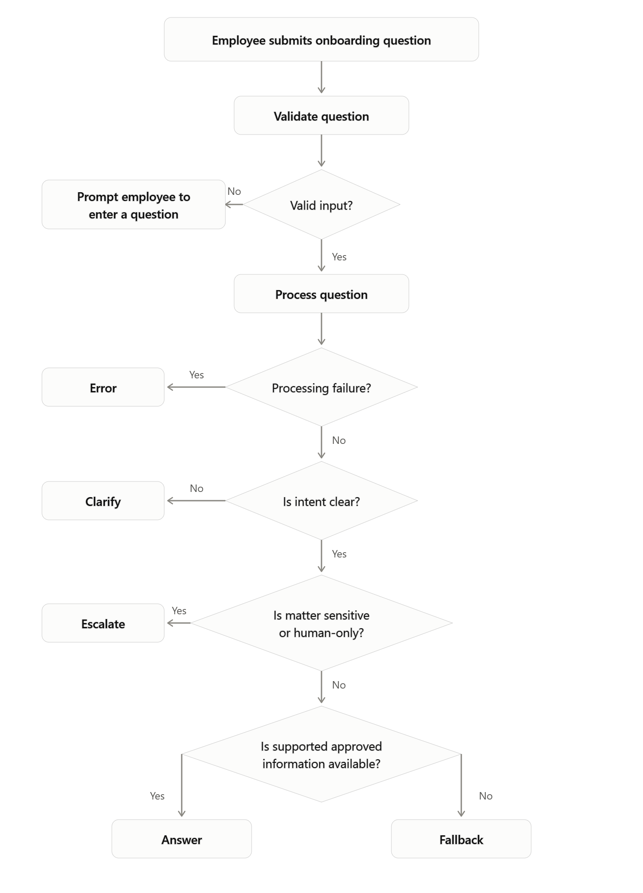
Depending on the type of question, the requirements identify possible pathways such as HR support, IT support, a manager, or a human HR representative. The handoff must also be visible to the employee. The interface should not silently redirect the question or leave the employee thinking the AI has resolved the issue. The user must clearly understand that further human assistance is needed.
If processing fails at any stage, the system returns the ERROR state rather than continuing through the normal decision flow. The assistant must also not confirm that a matter has been sent or escalated to a human unless the MVP performs and confirms that action.
Matter Type | Human Support Pathway
HR-related matter | HR Support
System/access issue | IT Support
Manager-specific operational question | Manager
Sensitive/uncertain HR matter | Human HR representative

The support pathway type is defined by the requirements, while the exact human contact remains to be confirmed for implementation.

User-Facing States
The current Employee Onboarding interface demonstrates the normal interaction flow, including a loading state while a question is being processed and a successful-answer state when supported information is available.
The technical fallback and escalation approach extends this same interaction model by defining additional outcomes for CLARIFY, FALLBACK, ESCALATE, and ERROR. These states can use the existing chatbot response area while presenting different messages depending on the outcome of processing.
Technical State | When It Occurs | User-Facing Behaviour
LOADING | The employee has submitted a question, and the system is processing it. | Display a loading indicator until processing is complete.
ANSWER | The question is supported and relevant approved onboarding information is available. | Display the supported answer in the chatbot response area.
CLARIFY | The question is unclear or does not contain enough information to determine the employee’s intent. | Ask the employee a short follow-up question requesting the missing information.
FALLBACK | The question is unsupported, unrelated to onboarding, or cannot be answered using the approved information available to the MVP. | Clearly explain that the assistant cannot provide a supported answer.
ESCALATE | The question is sensitive, requires human judgement, or involves an action outside the assistant’s authority. | Clearly inform the employee that human assistance is required and provide the available support guidance.
ERROR | A technical or processing failure prevents the assistant from completing the request. | Inform the employee that the request could not currently be processed and provide an appropriate retry or support option.

Keeping these states separate ensures that the employee receives a clear and appropriate response for each situation instead of seeing the same generic error message for every unsuccessful interaction. This is consistent with the Sprint 2 requirements for unsupported-question handling, clarification, fallback and human escalation.

Open Questions / Implementation Considerations
The main fallback and escalation behaviour has been defined, but a few implementation details still need to be confirmed before the final Sprint 2 implementation.
Human Escalation Contact
The exact human contact for an escalated question is not yet confirmed. Depending on the type of issue, the employee may need to be directed to HR, IT support, or their manager. The implementation should therefore avoid hard coding a specific contact until the final support pathway is confirmed.
Escalation Method
It also needs to be confirmed whether the MVP will send or create an escalation request, or whether it will only direct the employee to the appropriate human contact. Until this is confirmed, the assistant should not state that a request has been “sent” or “submitted” unless that action has occurred.
Low-Confidence Handling
The requirements do not currently define a numerical confidence threshold. For the Sprint 2 MVP, low-confidence behaviour should therefore be based on situations such as unavailable approved information, insufficient information to support an answer, or unclear employee intent. A numerical threshold should only be introduced if the final implementation provides and validates a meaningful confidence value.
These items do not change the overall fallback and escalation flow, but they should be confirmed before the final behaviour is locked into the implementation.

